**Problem statement:**  Suppose that we were to rewrite the **for** loop header in line 10 of the COUNTINGSORT as 10 **for** j = 1 **to** A.*length*

Write a program, so that the algorithm still works properly.

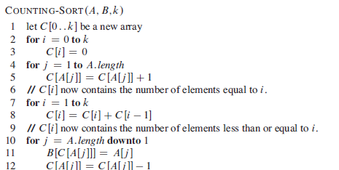

**Also submit the document including algorithm, time complexity and screenshot.**